# **Crowdfunding Data Analysis**

**Crowdfunding success correlation with the Goal set:**

Break the Projects based on Goal set – Low (up to $14,999), Medium ($15,000 to $34,999) and High ($35,000+). In the low-cost projects, it was noted that Goal set between $1,000 and $4,999 has the highest success rate of 83%. The goal set between $15,000 to $24,999 and $30,000 to $34,000 has the highest success rate of 100% across all the goals. Goals set greater than $50,000 had the least success rate of 37%.



**Limitations:**

The total number of projects that had 100% success rate were only #25. While the number of projects in the lower goal of less than $10,000 were #597. This means, the goal set from $1,000 to $4,000 has a higher success rate of 83% considering the factor that the total projects of #231.

**Additional Graph from Pivot table:**

The below graph was produced from Pivot table containing Success and Failure percentage of the project corresponding to each sub-category. It was noted that Audio and World music sub-category had 100% success rate, followed by Web with the success rate of 71%. It should be noted that the total number of projects in Audio and World music was four and three respectively. 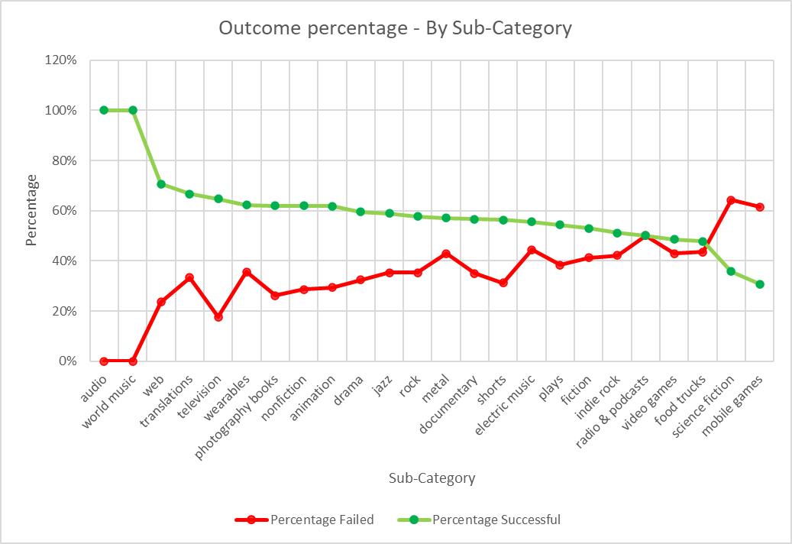

**Statistical Analysis:**

Below is the summary of statistical table based on number of campaign backers. It was noted that when the number of backers were increased, the more successful was the project. This is supported also by the Mean value in the below table.

The variance value of successful campaign is 1603374 when compared to the failed campaign value of 921574. This is because, the larger of number successful projects has the number of backers skewed towards higher value from the Mean than the failed projects.



By

Vijayakrishnan Mani

23rd November 2023